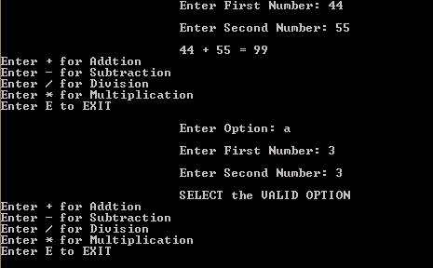

**PROGRAMMING FUNDEMENTAL PROJECT PROPOSAL**

UNIVERSAL CALCULATER

|  |  |
| --- | --- |
| Project Name | Universal Calculator |
| Course Name | Diploma in Computer System Design |
| Batch | 17.3F |

Member Details

|  |  |
| --- | --- |
| **Name** | **Index Number** |
| H.S.D.Indrajith | CODCSD173-046 |
| J.L.R.R.P.Perera | CODCSD173-051 |
| Y.G.Pramuditha Malhara | CODCSD173-056 |
| M.W.G.Tharindu Buddhika | CODCSD173-062 |

CONTENT

1. INTRODUCTION
2. PROBLEM DESCRIPTION
3. SOLUTION
4. CONCLUSION

Introduction

A calculator Is a device that performs arithmetic Operations on numbers.

The simplest calculators can do only addition, subtraction, multiplication and division. More sophisticated calculators can handle exponent roots, logarithms, trigonometric functions. Internally some calculators perform these functions by repeated processes of addition.

In addition to the features of an equal calculator our calculator features

matrix calculation, power, base converter and the same calculator. This calculator consists of 4 main parts.

* + - 1. Standard calculator
      2. Scientific calculator
      3. Unit calculator
      4. Matrix calculation

The components of the above components are as follows

1. Standard calculator

Addition

Subtraction

Multiplication

Division

1. Scientific calculator

Square

Power

Factorial

Base converter

1. Unit calculator

Distance

Mass

Area

1. Matrix calculation

Addition

Subtraction

Multiplication

Determine

Inverse

Problems Description

The final answer is not correct because of taciturn errors in solving mathematical problems.

* To find out the final answer to the questions that are required for the long calculation.
* To check the accuracy of the answer with a long calculation.
* To find the inverse of a matrix.
* Finding the factorial notation of a number can be done in less time.

To overcome the problems encountered in overcrowding.

SOLUTION

CONCLUSION

* After we will complete this project everyone can make any question in this topics specially Metricx problems.
* This Universal Calculator save more time of student life

Benefits of Universal Calculator

* + This program allocates small size of space in computer hardware
  + There include new features
    - Unit calculator
    - Matrix calculation